**Noisettes Promo Update**

Single – That Girl / Winner Out Now

Album – “Contact” August 27th 2012

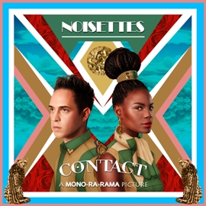

[http://www.noisettes.co.uk](http://www.noisettes.co.uk/)

<http://www.twitter.com/noisettes>

<http://www.facebook.com/thenoisettes>

<http://www.youtube.com/NoisettesOfficial>

<http://soundcloud.com/noisettes-official>

**PRESS**

**Overview:**

* **This week the Independent feature ran (11th August) - perfect timing for the single release. The piece also ran online:**

[**http://www.independent.co.uk/arts-entertainment/music/features/making-some-noise-for-the-noisettes-8026718.html**](http://www.independent.co.uk/arts-entertainment/music/features/making-some-noise-for-the-noisettes-8026718.html)

* **This week we also completed a shoot with FAULT magazine. The feature with Dan and Shingai will run in their Autumn issue and include great plugs for the releases.**
* **We’ve confirmed great album reviews across the board - So far, we have; Glamour, Q, The Fly, Clash, Mojo, The Observer, The Guardian, The Times, The Sunday Times Culture, Grazia, Heat, New, Star Magazine, Time Out, Daily Star Playlist, The Sun, Metro and the Daily Mirror.**
* **This week we also completed phoners with Clash - to run with the feature out at the end of August and the Observer magazine which will run with Shingai’s cover on 26th August (day of album review).**
* **This week we’ve completed the PR for the tour announcement and announced the tour to all of our contacts.**
* **We will be completing phoners with the weekly mags next week to run the week of release - Grazia, LOOK and More! would all like to scehdule time in with the band - Now that we have completed the credible, broadsheet/music press, it’s important that their profile is in the weekly magazines in the right way. These magazines have huge circulation and are the perfect target audience for their fans. We’ve also completed an interview with Joe Mott at the Daily Star who has a muisc column over the weekend - The interview will be the lead interview the week of album release.**

Coverage achieved (print)

|  |  |  |
| --- | --- | --- |
| Publication | Description | Date Ran |
| Sytar Magazine | Shingai lead interview | 14th August 2012 |
| Star Magazine | 4 star single review | 14th August 2012 |
| OK | The Huffington Post party pic | 14th August 2012 |
| The Independent | Feature | 11th August 2012 |
| The Sun | SFTW - single review | 10th August 2012 |
| ES Magazine | COVER | 10th August 2012 |
| The Blackpool Gazette | Blackpool Illuminations story | 9th August 2012 |
| The Sun | Bizarre - Shingai and Jessica Ennis story | 9th August 2012 |
| Glamour | Album of the month | 9th August 2012 |
| ARISE | Shhot and feature | 8th August 2012 |
| The Independent | BT London Live Review | 8th August 2012 |
| The Evening Standard | BT London Live mention - Picture | 7th August 2012 |
| Daily Star Playlist | BT London Live - lead story | 7th August 2012 |
| Daily Mirror | Lead story – The Ticket | 3rd August 2012 |
| PRIDE | Cover | 2nd August 2012 |
| Metro | Metro Life – African fashion feature | 2nd August 2012 |
| Music Week | Upcoming album | 19th July 2012 |
| The Daily Mirror | Feature | 19th July 2012 |
| The Times | T2 | 11th July 2012 |
| Daily Echo | Cover of the entertainment section | 29th June 2012 |
| Daily Star | Playlist feature - album announcement | 29th June 2012 |
| Daily Star Sunday | Shingai quote | 24th June 2012 |
| Mizz Magazine | Poster | 28th June 2012 |
| The Financial Times | Shingai interview - BT River Of Music | 18th June 2012 |
|  |  |  |
| The News | Portsmouth local paper - Blissfields feature | 12th June 2012 |
| Stylist | Shingai Scoop Feature | 6th June 2012 |
| Telegraph | Feature | 28th April 2012 |

Overview:

* It’s been another busy press week for the guys. The campaign feels like it is really moving in the right direction and the responses that I’ve had on the album have been very positive.
* This week we completed the Independent feature interview with Elisa Bray which went really well. The independent requested a shoot with the guys to run with the piece which is a great sign and means that the feature is likely to be larger than we orginally expected. The shoot was done at Shingai’s house on 26th July. The piece is due to run W/C 13th August which is perfect timing for the single release.
* This week we’ve confirmed two more shoots with the guys. We will be doing a shoot and interview with Clash magazine (for their fashion issue) which is due out at the end of August and Topman’s Generation magazine. We have also been told that if the Clash shoot goes well that it could be a cover option for them which would be incredible and perfect postioning for the band.

1. Shingai’s interview with the Sheffield Telegraph ran today ahead of Sheftival - great regional coverage for the guys:

<http://www.sheffieldtelegraph.co.uk/lifestyle/listings/music/sheftival-ey-up-sheffield-it-s-the-noisettes-audio-1-4781571>

* This week we also completed an interview with the Daily Mirror’s music section, The Ticket. The interview will run as the lead interview on 3rd August and include great plugs for the single and album. This will be the only piece of tabloid press that we’ll do for the single to ensure that their profile is present in this area without us having to do tabloid chats.
* Shingai’s cover with PRIDE is due to hit the shelves early next week.
* We have some weekly magazine chats to do with the guys next week - Star magazine, Grazia, More! and LOOK would all like to run interviews - It’s important that all of the credible press runs before these do so we will be getting them to run the week of release.
* Shingai will be featuring on the cover of the Observer Magazine for their Africa Express feature. The cover is due to run at the end of August with the shoot taking place on Monday 30th July.
* Shingai’s fashion feature with Metro is due to run on Thursday 2nd August and will be another great positioning piece as they will be running an image on the cover.

Also confirmed is:

* + PRIDE - Cover feature for their September issue
  + Arise
  + Blackhair magazine
  + Blues & Soul magazine
* We’re currently setting up another press day for Tuesday 24th July as we’ve got lot’s of great things confirmed to run around the release:
  1. The Independent - Music feature to run the W/C 13th July. Elisa Bray, the Music Editor will be doing the interview
  2. The Observer Magazine - ‘A Room Of My Own’ feature
  3. Daily Mirror, The Ticket, Lead interview - will run 10th August
  4. Project Magazine
  5. Star Magazine - lead interview
  6. LOOK
  7. More! Magazine
  8. Company magazine - fashion feature - September issue and will be on the shelves for 6 months!
* We confirmed and completed two great fashion pieces for Shingai this week. Shingai did a shoot with ARISE which will run in their September issue with an interview. Shingai is also part of a feature on African fashion in the Metro which is due to run on August 2nd. They’ll be using Shingai as the lead image for the piece. These fashion endorsements are great for the profile of the band.
* This week the Daily Mirror ran a great feature piece on the BT River of Music - the piece ran on 19th July and included a great plug for the single and album.
* Music Week included ‘Contact’ in their upcoming album section - ran 18th July.
  + 1. We’ve confirmed a feature with The Independent with Elisa Bray, Music Editor of The Independent will run the W/C 13th August.
    2. We’ve confirmed a feature with The Sheffield Star which will be taking place on July 17th to run around their Sheftival performance.

1. We’ve confirmed a feature piece in the Daily Mirror’s music section, The Ticket. The interview will run as the lead interview the week of single release - August 10th

* This week we also confirmed and completed a great feature piece with the Daily Mirror for the BT River of Music. Great feature piece for the guys that will include a great plug for the releases. The feature is due to run on 19th July.
* We’ve had a lot of interest for the guys and have so far confirmed:
  + ASOS - shoot which we’ve already completed and will run at the end of August in their September issue
  + Star Magazine - Feature
  + Project magazine - Feature
  + The Sunday Express - S Magazine, Closet Feature
  + More! Magazine
  + LOOK interview
* Glamour have confirmed that ‘Contact’ is their album of the month for their August issue, Q magazine and The Fly have also confirmed that they will be reviewing the album. Single reviews have been locked in with all of the weekly magazines, broadsheets and tabloids.

**RADIO**

**We ended w/c 13.08,2012**

**Air play Position : 19  
  
Total plays : 1,077   
  
Total Radio Two plays : 16  
  
Total Audience : 29,472m**

Added Straight to Radio 2 – B-List w/c 16.07.12

Shingai is doing a phoner with Jon Holmes (R2) and taking part in Ken Bruce Popmaster Quiz

Dermot O’Leary play 21.07.12

(As of 24th July)  
Total plays : 74  
Total Radio Two plays : 2  
Total Audience : 2.64m

We ended last week with:  
Total plays : 176  
Total Radio Two plays : 1  
Total Audience : 1.14m

We begin this week with:  
Total plays : 27  
Total Radio Two plays : 1  
Total Audience : 207k

**Radio 2:**  
Graham Norton / Radio 2 exclusive first play of That Girl July 7th  
Graham Norton / Radio 2 play of That Girl July 14th  
Dermot O’Leary session booked to tx on August 4th  
 **Radio 1:**  
Play of Winner (Steve Smart/Westfunk) on Danny Howard’s Dance Anthems June 16th  
**Other:**  
5 Live – Victoria Derbyshire interview confirmed for August 13th  
Gaydar Radio have been playing the Steve Smart/Westfunk remixes  
BBC London Late Night Session with Jo Good confirmed for 19th August  
Radio Four / Women’s Hour Interview + Session tx’ed in June

**TV**

**Confirmed TV**Afrobuzz (SKY 218) interview and video – 25/7, 26/7 & 27/7   
T4 (Ch 4) interview and acoustic - 4/8 or 5/8 TBC  
Freshly Squeezed (Ch4) interview and video - 15/8  
The Beat (ITV2) performance of “That Girl” 6/8   
Album Chart Show Spotlight (Ch4) interview - 20/8  
BBC Breakfast (BBC1) performance and interview - 29/8  
Matthew Wright Show guest appearance – w/c 3/9  
  
**Video playlists**VH1 Brand New  
The Box  
4 Music – spot plays  
QTv – spot plays  
Clubland  
  
**In discussion**Sunday Brunch  
Gino and Mel Let’s Do Lunch  
Sky Sunrise  
London Tonight  
Andrew MarrCeleb Juice  
Chart Show chart-hosting  
MTV content

**ONLINE**

**Here's a concise update on everything online. We have the following to run...  
- Gigwise - 2 x track session - 1 x live this weekend / 1 x next week   
- Digital Spy - Interview - live week of release   
- Official Charts Company - Filmed Interview - live week of release   
- Vogue - What We're Wearing on Vogue's Facebook - live week of release  
- Vogue - The Culture Edit blog - 5 x track playlist**

**Promo for Wed 22nd August**

**- The Outnet - 3 hr filmed shoot with Shingai only**

**- Glamour - Phoner**

**-** [**Look.co.uk**](http://Look.co.uk) **- Abbie - Phoner**

**- Metro Online - Face To Face Interview**

**- Gigwise - Phoner**

**- Yahoo OMG – Phoner  
- Music News - Face To Face Interview**

We're also looking to book the SBTV session in soon - we've proposed that the band do a collaboration with Lemar - we're waiting on feedback from Shingai & Dan. SBTV would film 1 x song of Noisettes', 1 x of Lemar's and a collaboration between the two.

In other news, BBC Music have published their album review - despite the first line, it's a very complimentary review! **BBC Music** **- Album Review - Good Review**<http://www.bbc.co.uk/music/reviews/9dj9>

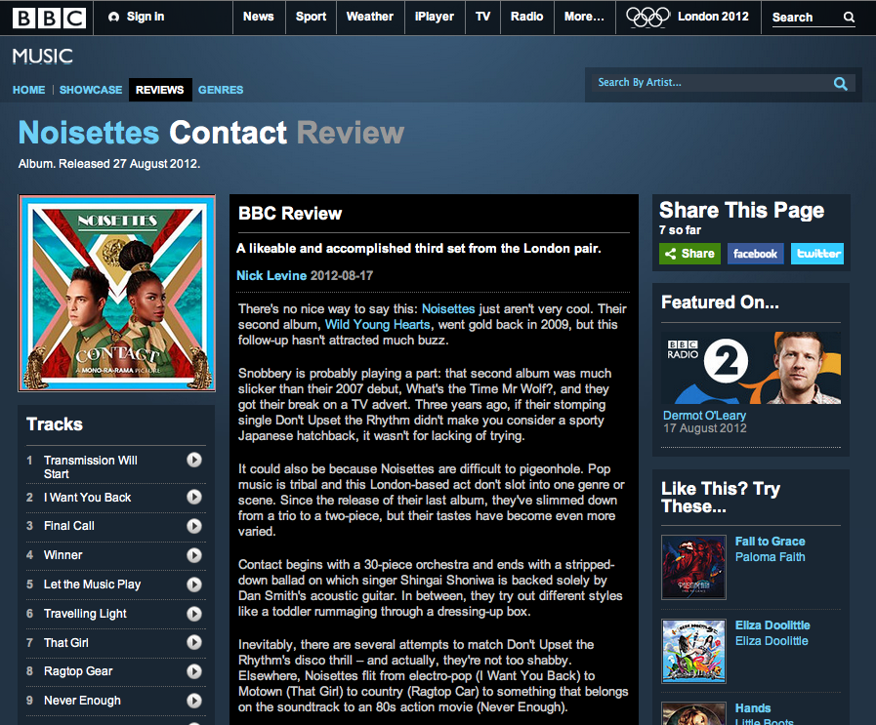

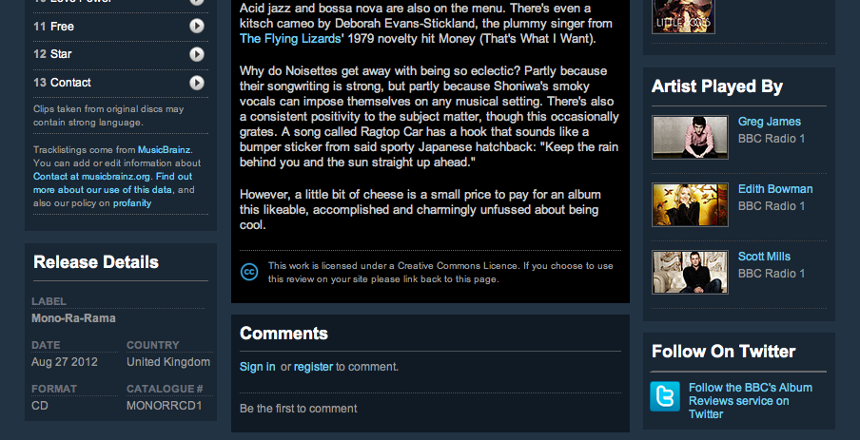

Here's the latest coverage for That Girl, plus a great preview of BT River Of Music on BBC News and a piece on The Huffington Post's First Birthday Party.

That Girl is currently at #11 on the 'no remix' Hype Machine chart - (screen grab below)

<http://hypem.com/track/1ndtq/Noisettes+-+That+Girl>

BBC News <http://www.bbc.co.uk/news/uk-england-london-18896369>

The Huffington Post <http://www.huffingtonpost.co.uk/2012/07/19/huffington-post-birthday-bash-ivy-noisettes_n_1685275.html>

BLOG COVERAGE

Loft 965 <http://loft965.com/2012/07/18/video-premiere-winner-by-the-noisettes/>

Eye Wear What Eye Want <http://eyewearwhateyewant.blogspot.co.uk/2012/07/shingai-shoniwa-wears-what-she-wants.html>

Azaria La Mode <http://www.azarialamode.com/?p=3882>

My Flash Trash <https://www.myflashtrash.com/blog/shingaishoniwawearsblingdeenie/>

Cmon Good <http://cmongood.com/video/video-shingai-shoniwa-of-the-noisettes-performs-dont-upset-the-rhythm/>

Nuwave Pony <http://nuwavepony.com/2012/07/19/noisettes-winner-official-video/>

Vakeo Music <http://vakeomusic.com/web/2012/07/11/noisettes-winner-official-video/>

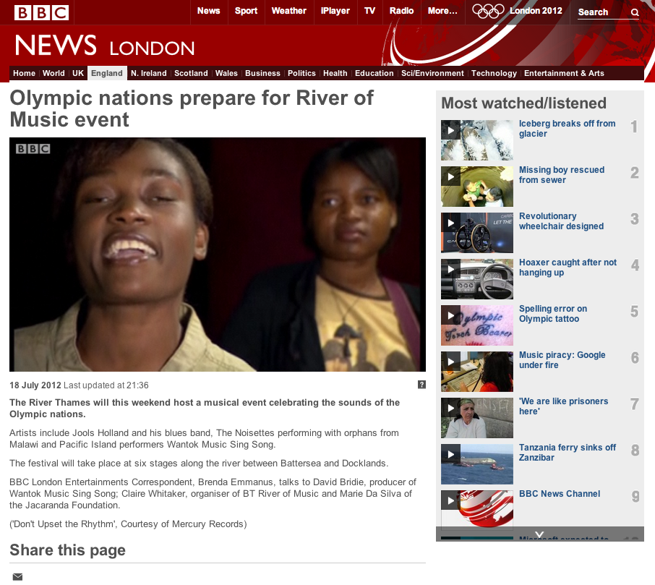

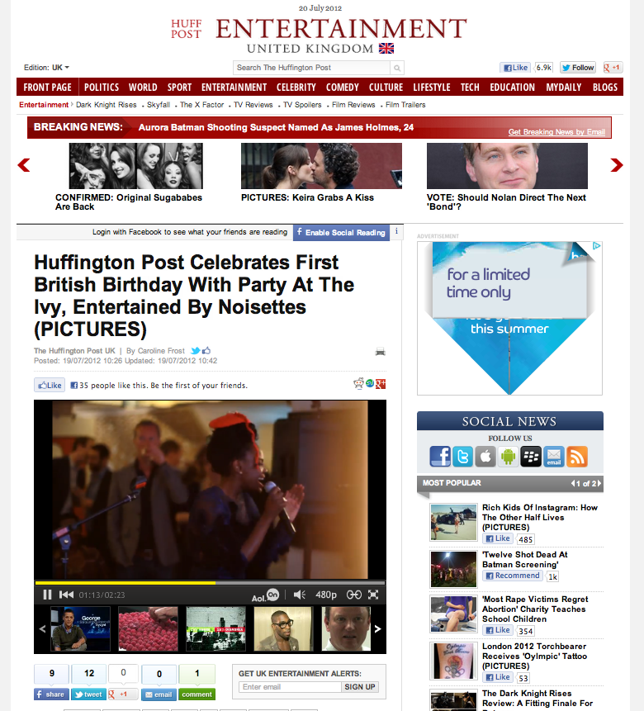

**Hype Machine**

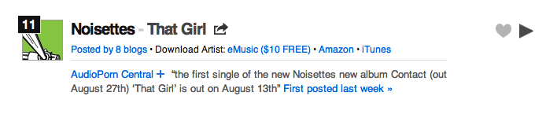

**Confirmed / Requested Online Features**  
WotYouGot - Filmed Interview   
Official Charts Company - Filmed Interview  
The Fly - Courtyard Session  
Digital Spy - Filmed / Face to Face interview   
Studio Lux - Face to Face interview (Shingai)  
Music News - Interview

**Confirmed Features - To Do on email**  
Topshop - Q&A - to run post Apartment 58 show (waiting on answers from Shingai)  
Vogue - The Culture Edit Blog - Playlist   
Twin Magazine - Boudicca Fox-Leonard - Playlist (Shingai)

**Confirmed Features**  
Vogue - Today I'm Wearing - w/c August 27th on <https://www.facebook.com/BritishVogue> (Shingai & Dan)  
The Huffington Post - regular blog (next one due from Shingai)   
----------------------

**Popjustice**<http://www.popjustice.com/thenews/noisettes-have-some-new-artwork-for-a-new-single-from-their-new-album/95667/>

**Pinboard Blog**<http://pinboardblog.com/2012/07/mp3-noisettes-that-girl/>

**Punchbowl Blog**<http://punchbowlblog.com/2012/07/11/new-music-noisettes-that-girl/>

**Audio Porn**<http://audioporncentral.com/2012/07/noisettes-that-girl.html>

**Walk Between The Lines**<http://walkbetweenthelines.tumblr.com/post/27067830707/fiddleabout-the-noisettes-that-girl>

**Soul Bounce**<http://www.soulbounce.com/soul/2012/07/noisettes_may_have_a_winner_on_their_hands.php>

**Fashions Finest**<http://fashionsfinest.com/features/entertainment/item/2353-noisettes>

**Musically Sinful**<http://musicallysinful.com/2012/07/11/noisettes-that-girl/>

**This Is RnB**<http://www.thisisrnb.com/2012/07/new-music-noisettes-the-girl/>

**The Hip Hop Chronicle**<http://www.thehiphopchronicle.com/noisettes-that-girl/44292/>

**Mad Ice**<http://mad-ice.com/2012/07/11/new-music-noisettes-that-girl/>

**The Music Hoarder**<http://www.themusichoarder.com/post/26998036564/noisettes-that-girl-admittedly-i-wouldnt>

**Maroon Cafe**<http://www.cafemaroon.com/listening-section/stream-noisettes-that-girl/>

**Best In New Music**<http://www.bestinnewmusic.com/2012/07/noisettes-that-girl.html>

**Cmon Good**<http://cmongood.com/music-goods/audio-the-noisettes-that-girl/>

**I Love Music Pop**[http://www.ilovemusicpop.net/2012/07/noisettes-that-girl/](http://www.ilovemusicpop.net/2012/07/noisettes-that-girl/%09)

**Entertainment Empire**<http://entertainmentempire.blogspot.co.uk/2012/07/new-song-that-girl-noisettes.html>

**Konbini**<http://www.konbini.com/en/music-en/that-girl-lead-single-noisettes-contact-ep-listen/>

**Josep Vinaixa**<http://www.josepvinaixa.com/blog/noisettes-that-girl-single-premiere/>

**Turbo City**<http://turbocityofficial.blogspot.co.uk/2012/07/noisettes-that-girl.html>

**Gidi Live**<http://gidilive.com/new-music-noisettes-that-girl/>

**Kick Mag**<http://www.kickmag.net/2012/07/the-noisettes-that-girl/>

**The Re-View**<http://there-view.tumblr.com/post/27059262321/noisettes-debut-new-single-that-girl>

**Wonky Sensitive**<http://wonkysensitive.blogspot.co.uk/2012/07/noisettes-that-girl.html>

**Auburn Butterfly**<http://auburnbutterfly.blogspot.co.uk/2012/07/noisettes-that-girl.html>

**Newsbeat Daily**<http://newbeatsdaily.blogspot.co.uk/2012/07/noisettes-that-girl.html>

**Music Is Like Peanuts**<http://www.musicislikepeanuts.com/2012/07/noisettes-winner-video-that-girl-audio.html>

**Sound On Mars**<http://soundonmars.com/2012/07/12/new-music-noisettes-that-girl/>

**Monica Mania**<http://monicamania.blogdrive.com/archive/6640.html>

**Digital Spy**<http://www.digitalspy.co.uk/music/news/a392841/noisettes-debut-new-single-that-girl-listen.html>

**Gigwise**<http://www.gigwise.com/news/74477/noisettes-unveil-first-single-from-new-album-contact---listen>

**Music News**<http://www.music-news.com/shownews.asp?H=Noisettes-to-release-That-Girl-as-first-single-from-new-album&nItemID=54112>

**Soul Culture**<http://www.soulculture.co.uk/music-blog/newmusic/the-noisettes-return-with-new-single-that-girl-new-music/#axzz20OnM2crA>

**Stylish Thought**<http://stylishthought.com/the-arts/music/on-repeat-noisettes-that-girl/>

**Put The Needle On It**<http://puttheneedleonit.com/2012/07/09/artwork-win-and-were-one-down-from-the-noisettes/>

**Verse Magazine**<http://www.versemagazine.com/2012/07/11/uk-homegrown-the-noisettes-that-girl/>

**Entertainment Focus**<http://www.entertainment-focus.com/news/that-girl-is-new-noisettes-single>

**Clixie** <http://www.clixie.co.uk/noisettes-announce-new-album-details/>

**Entertainment Empire**<http://entertainmentempire.blogspot.co.uk/2012/07/new-song-that-girl-noisettes.html>

**REGIONAL RADIO**

**A further increase in playlists this week pushing total to 133.**

**Tracking showing 1142 plays for past 7 days / 3409 plays / impact of 67.89 million.**

**Recent promo delivered a successful ISDN day. We continue to focus radio push for increased rotation / chasing remaining stations for adds.**

**We will update radio again next week with our weekly digital / soundcloud mailshots to maintain awareness and easy review.**

**Album stock received and placed for comps / album of the week features. Full breakdown of stations with next week’s report.**

**Real Radio/Smooth Radio Event on 31 Aug - Blackpool Illuminations PA.**

Phoner with Sue Marchant BBC Eastern Counties 6th July

**GMG**Smooth Radio – confirmed for **album of the week** from 26th August.

**LIVE**

22nd July Olympic River of Music , African stage London Pleasure Gardens Stage time 6.30pm

Aug 4th Sheftival, Don Valley Stadium Sheffield,

Aug 5th Hyde Park BT Vision stage

Aug 9th Hyde Park Magic Radio Stage

Sept 1st Jamie Oliver’s Big Festival with Alex James, Kingham Oxfordshire

**CLUB**

“Winner” peaked at No.7 in Music Week Club Charts and No. 10 in Music Week Pop Charts

**ENDS**